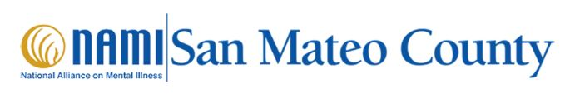

National Alliance on Mental Illness (NAMI)
NAMI San Mateo County
NAMI offers support, education, compassion and practical experience, to anyone needing to educate themselves about mental illnesses and their treatment or a loved one in San Mateo County.
NAMI HelpLine | NAMI: National Alliance on Mental Illness
The NAMI HelpLine is available Monday through Friday 10 am – 10 pm ET 1-800-950-NAMI (6264), text “HelpLine” to 62640 or email helpline@nami.org
Family Programs (courses)
Family-to-Family Program is a free 9-week course for family caregivers of individuals with severe mental illnesses.
NAMI Basics Program is a free 6-week course designed for parents and other primary caregivers of children and adolescents experiencing emotional and behavioral difficulties.
National Alliance for Mental Illness (NAMI) supports people and families who struggle with mental illness. They have ongoing Family and Peer Programs. They also have Support Groups for families and individuals.

